OUTPUT
Task 1: Total Trips
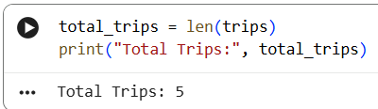
Task 2: Trips from Bangalore
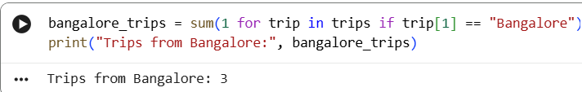
Task 3: Total Revenue
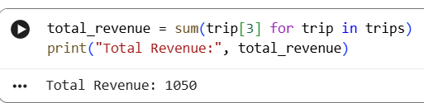
Task 4: High Distance Trips
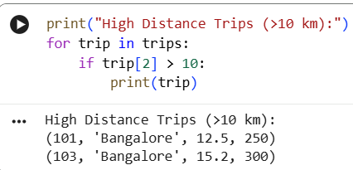
Task 5: Highest Fare Trip
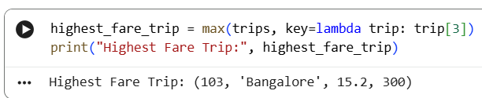
Task 6 (Bonus - Real Analyst Thinking
Find the average fare for Bangalore trips only.
